Weather Checker using OpenWeatherMap API

Introduction

This project is designed to check the current weather conditions of any city using the OpenWeatherMap API. The user enters a city name, and the application displays live weather information such as temperature, humidity, wind speed, and weather description. It is built using Python and Tkinter (for the Graphical User Interface).

Objectives

- To understand how APIs work in Python.
- To fetch real-time data from the OpenWeatherMap API.
- To display weather information in a user-friendly GUI.
- To learn the integration of backend (API calls) and frontend (Tkinter GUI).

Tools and Technologies

Tool | Description
Python | Programming language used to build the project.
Tkinter | Python library for creating the GUI.
Requests | Python module for making HTTP requests to APIs.
OpenWeatherMap API  URL: https://home.openweathermap.org/api_keys | Provides real-time weather data.

System Requirements

• Python 3.10 or above
• Internet connection
• Installed libraries:
pip install requests

Working of the Project

- The user enters the city name in the input box.
- When the 'Check Weather' button is clicked, the application sends a request to the OpenWeatherMap API.
- The API responds with weather data in JSON format.
- The program extracts useful information (temperature, humidity, etc.) and displays it in the GUI.
- The user can also save the weather report as a text file.

6. Code Explanation (Summary)

- `requests.get()` is used to call the API.
- The API key is stored in a variable and used to authorize requests.
- Tkinter widgets like Label, Entry, Button, and Text are used to design the GUI.
- Error handling ensures the app doesn’t crash if an invalid city name is entered.

7. Output

The GUI window displays:
- City Name
- Temperature (°C)
- Feels Like Temperature
- Weather Description
- Humidity (%)
- Wind Speed (m/s)
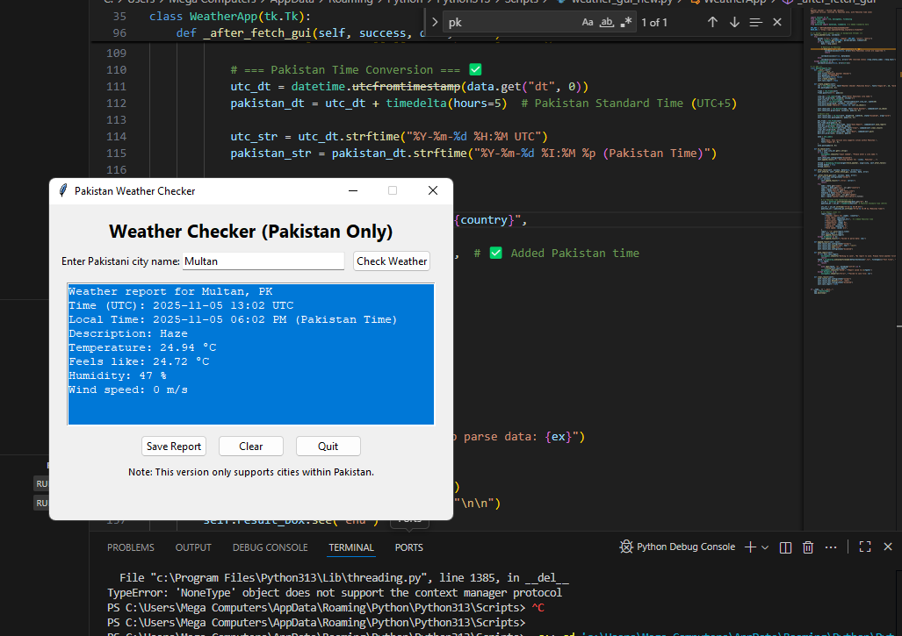

8. Results

The project successfully retrieves live weather data using an API and presents it in a clear graphical format. It helps users easily check weather conditions for any city worldwide.

9. Flow diagram
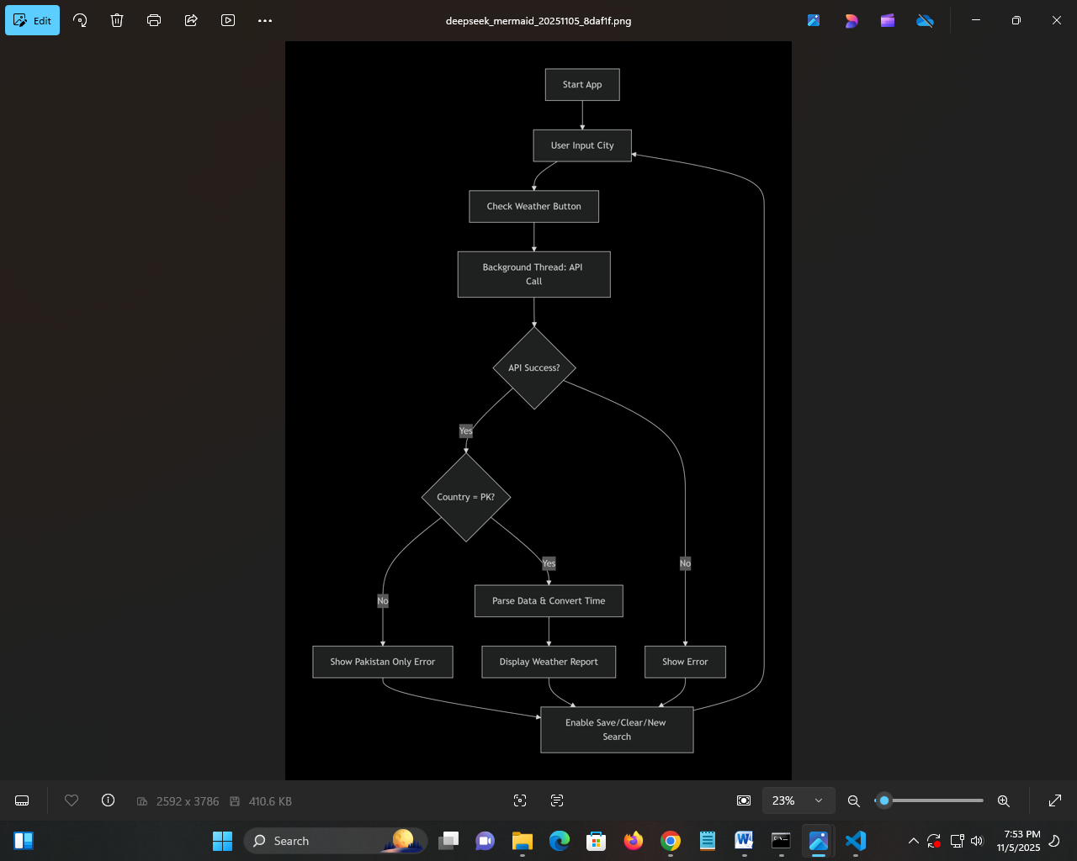

10. Conclusion
This project demonstrates the practical use of APIs and Python libraries for creating real-time applications. It enhances programming and problem-solving skills while giving experience in GUI design and data handling.

11. Future Enhancements
- Add a 5-day forecast option.
- Include weather icons.
- Display local time and sunrise/sunset.
- Build a mobile or web version.

